1. 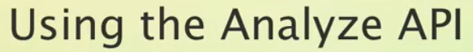
2. **Agenda**: To see analyze API to check how specific character filters, tokenizer, token filters handle text inputs.   
   What I want to do is to use the example sentence from the previous lecture and go for each step that the **standard analyzer** performs.
3. Since the **standard analyzer** doesn’t make use of a **character filter**. So, the first step is tokenizer namely the **standard tokenizer**.

So what we can do is to send post request to an API named **_analyze** and for this API, we don’t need to specify an index or type. So let’s send along a request body and specify a tokenizer.

Let’s run the query. See, apart from the tokens you also get additional information out of the analyze API such as **character offsets**.

So within the result, you can find a key named “**tokens**” containing an array of tokens.  
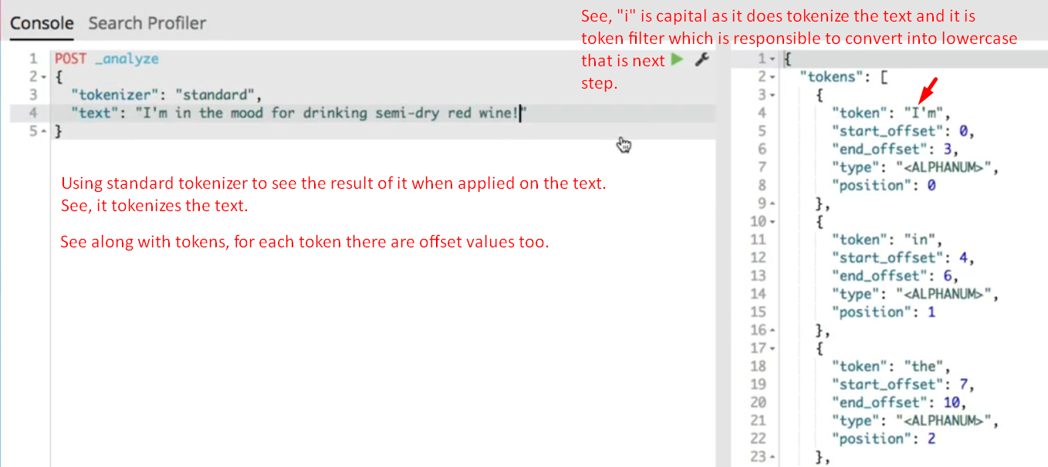

1. Let’s now talk about “token filters”.
   1. The standard token filters are “standard” and “lowercase” ones where the standard token filter doesn’t do anything as of today.
   2. So, we can use the lowercase token filter to see the same effect.  
      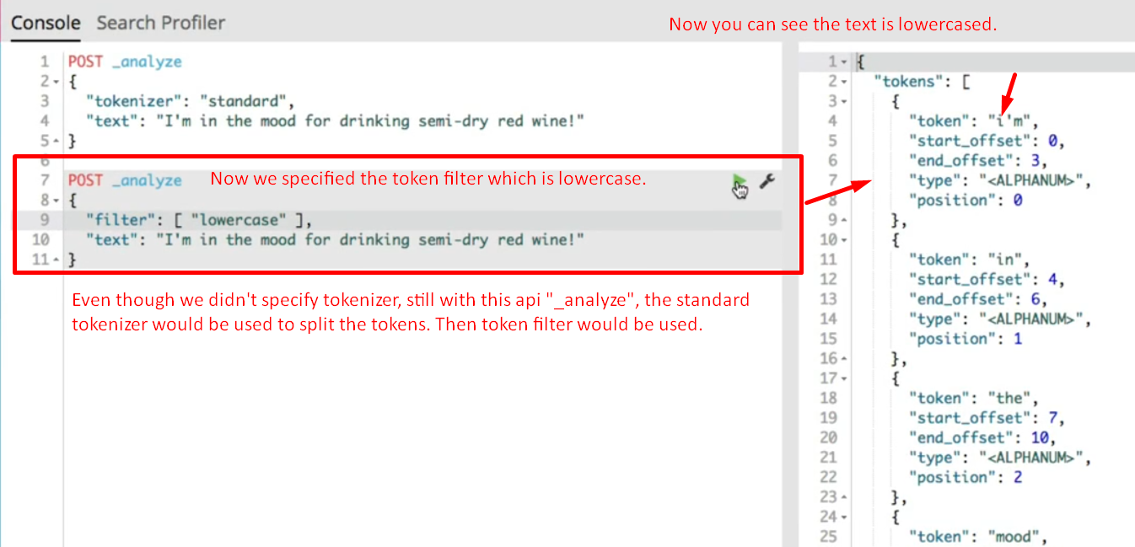
2. Let’s now see standard analyzer.
   1. If we run a query that specifies the analyzer as the standard one you’ll see the same results because it performs the steps you just saw.
   2. 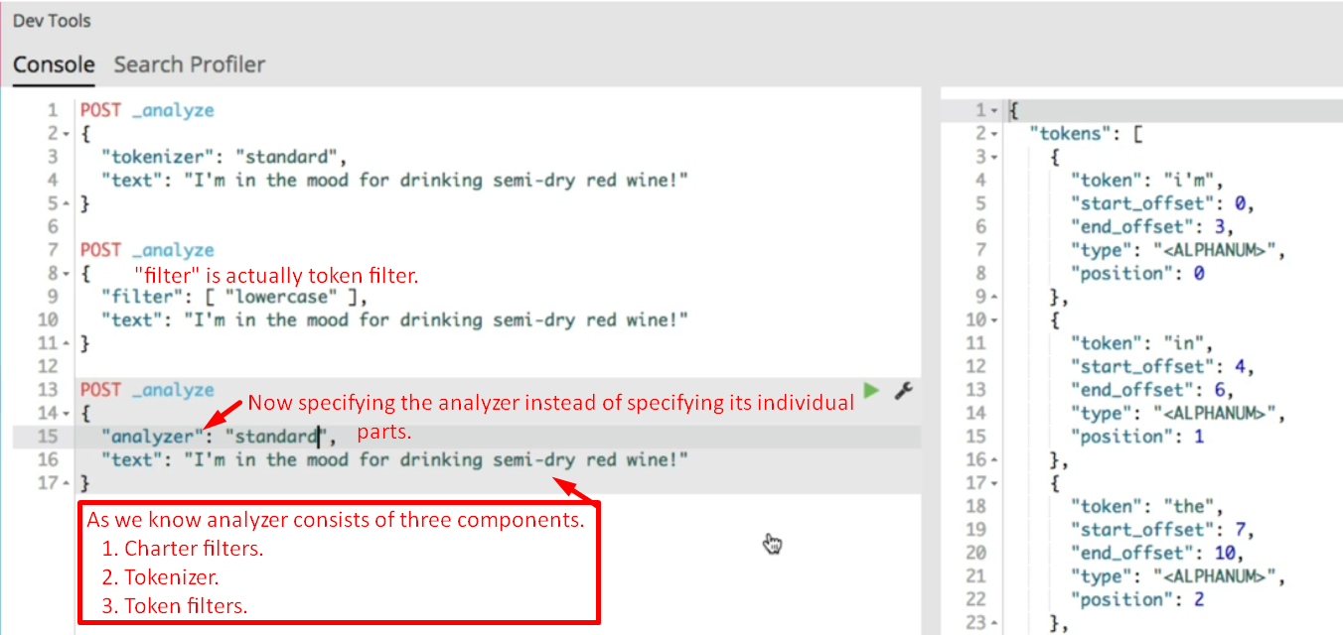

But what happens with the results of analysis process? Let’s see in the next lecture.